**COLONIAL NEWS**

Health Committee Newsletter SEPTEMBER 2024

Welcome to the Albert Gallatin School District Health Committee’s monthly newsletter. Each month this publication will provide our district with health and fitness information. Our goal is for our students, families, and staff to use this information to make healthy decisions and to live a healthy active lifestyle.

**Fall Fresh Start**

The fall season is upon us. As we move into this new season take some time to reset and adjust your routine. It’s always good to review your health goals and it’s never too late for a fresh start. Remember to keep it simple, get back to the basics by moving more, sitting less, eating more fruits and vegetables and be mindful of your stress levels.

(adapted from Source: ACSHIC)

**Back to school!**

Teachers and school staff do their best to help students be mindful of their personal hygiene habits. School custodians do their best to manage the relentless accumulation of germs by disinfecting and sanitizing.  
  
As parents/guardians, however, we must do our part in teaching our children ways to help them stay safe and healthy.

Here are a few suggestions to review with your child or consider doing as they go back to school:

* **School supplies**  
  Consider giving your child their own supplies and hand sanitizer.
* **Water fountains**  
  Give your child a personal water bottle so they will not have to drink from a water fountain. However, if they have to use a water fountain, remind them that they should touch their lips to the water stream, not the spout it comes out of.
* **Doorknobs, desks, and other surfaces**  
  These surfaces are full of germs. Teach your child to wash their hands and avoid touching their face after touching such surfaces.
* **Cafeteria**  
  Remind your child to wash their hands before and after they eat. Also, not to share utensils or to take bites from someone else’s lunch.
* **Computers**  
  Remind your child not to touch their face when they’re using a school computer, and to wash their hands before and after class. Give them their own headphones and clean them regularly.
* **Playgrounds and gyms**  
  Clean your child’s sports jerseys, protective equipment, and any other sweaty gear after they play, especially if they’re using gym mats or padding. Make a space at home where they can put their germy stuff so it can be disinfected.

(adapted from Source: ACSHIC)

**Take advantage of**

**the nice weather**

Enjoy the nice weather by taking a walk or riding a bike around your neighborhood. Research shows that getting outside can help your mental health, as well as your physical health.

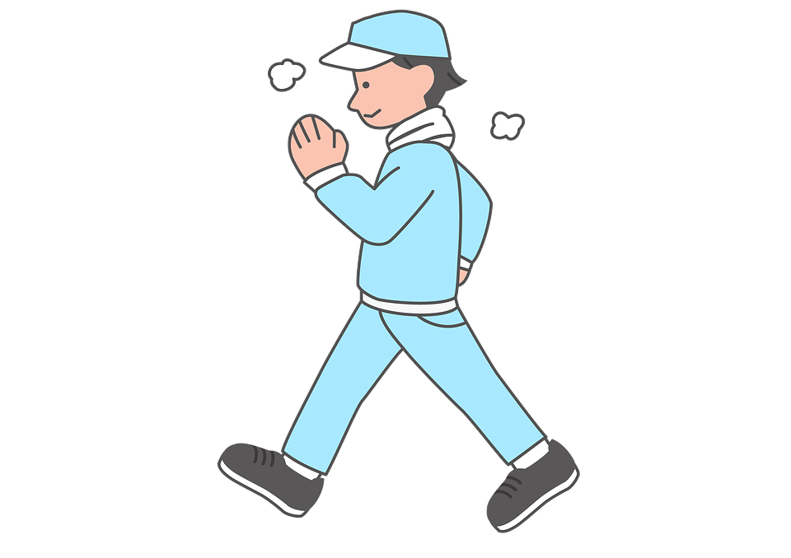 

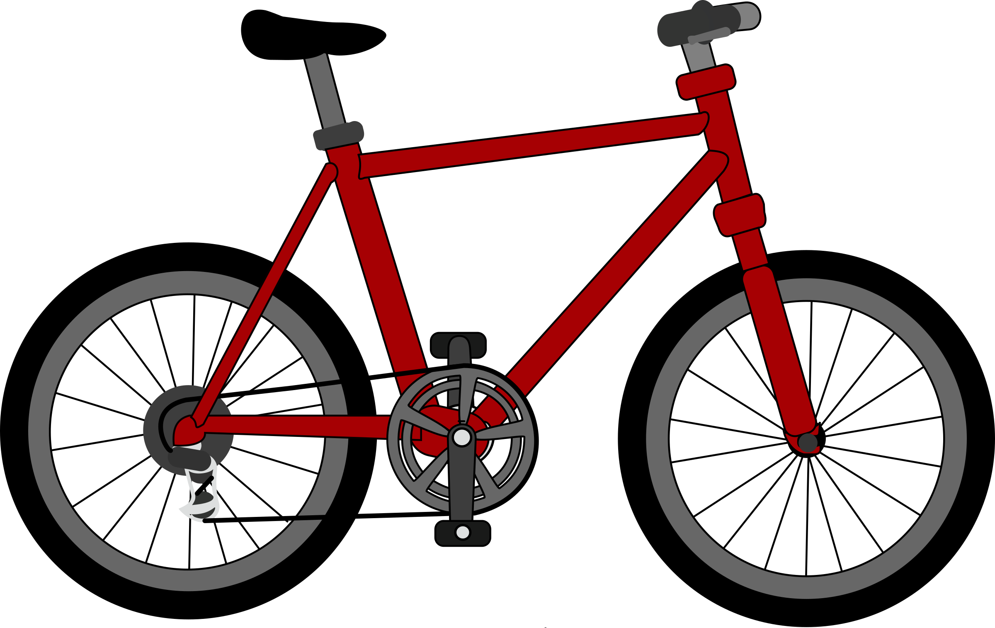

Prepared by Lisa Sumey, Central Office Secretary

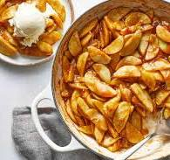

**Recipe of the Month**

**Baked Cinnamon Apple Slices**

**Ingredients**

* 4 medium Honeycrisp apples, peeled, cored and sliced 1/4 inch thick
* 2 medium Granny Smith apples, peeled, cored and sliced 1/4 inch thick
* ¾ cup light brown sugar
* 3 tablespoons cornstarch
* 2 tablespoons unsalted butter, melted
* 2 tablespoons lemon juice
* 1 ½ teaspoons ground cinnamon
* ¼ teaspoon salt

**Directions**

Preheat oven to 350°F. Combine Honeycrisp apples, Granny Smith apples, brown sugar, cornstarch, butter, lemon juice, cinnamon and salt in a large bowl; stir until the apples are fully coated. Transfer the mixture to a 9-by-13-inch baking dish; cover with foil. Bake for 45 minutes. Remove the foil and stir the mixture. Bake, uncovered, until the apples are tender and caramelized, about 10 minutes more. Let cool for 5 minutes before serving.

Source: www.eatingwell.com

   
  
  
  
   
  
 

# September is National Food Safety Education Month

Each September, in recognition of [National Food Safety Education Month](https://www.fda.gov/food/consumers/food-safety-education-month), health educators and consumers have focused on the most effective ways to avoid Foodborne illness, also called food poisoning. According to the Centers for Disease Control and Prevention, 48 million persons — or 1 of every 6 people get foodborne infections each year.

Foodborne illness is unpleasant and potentially dangerous for everyone, but you can avoid getting sick by following simple steps – Clean, Separate, Cook, Chill, and if at a higher risk, then possibly avoiding certain foods.

1. Clean: Wash your hands before and after handling food and wash your cutting boards, countertops, dishes, and utensils with hot soapy water. Rinse fresh fruits and vegetables under running tap water.
2. Separate: Separate raw meat, poultry, seafood, and eggs from other foods in your grocery cart. Use separate cutting boards for fresh produce and raw meat, poultry, seafood.
3. Cook: Use a food thermometer to ensure that raw meat, poultry, seafood, and egg products are cooked to a safe minimum internal temperature to destroy any harmful bacteria.
4. Chill: Refrigerate or freeze meat, poultry, eggs, seafood, and other perishables within 2 hours of cooking or purchasing. Refrigerate within 1 hour if the temperature outside is above 90° F. Never thaw food at room temperature, such as on the countertop.

(adapted from Source: www.fda.gov)

For more information visit

[www.fda.dot.gov](http://www.fda.dot.gov)